A53-AM,S-Colombia-Tairona-Gold Figurine-Crocodile-1000-1500 CE 2

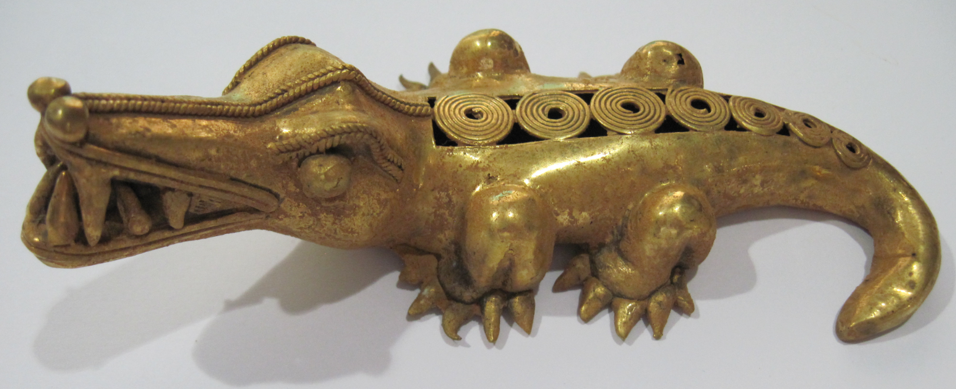 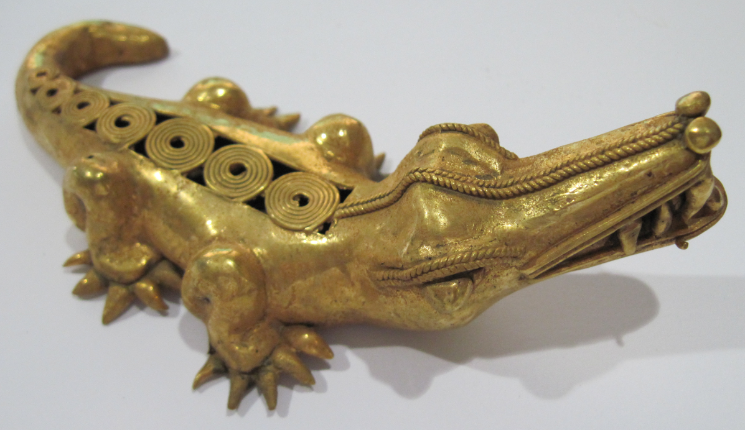

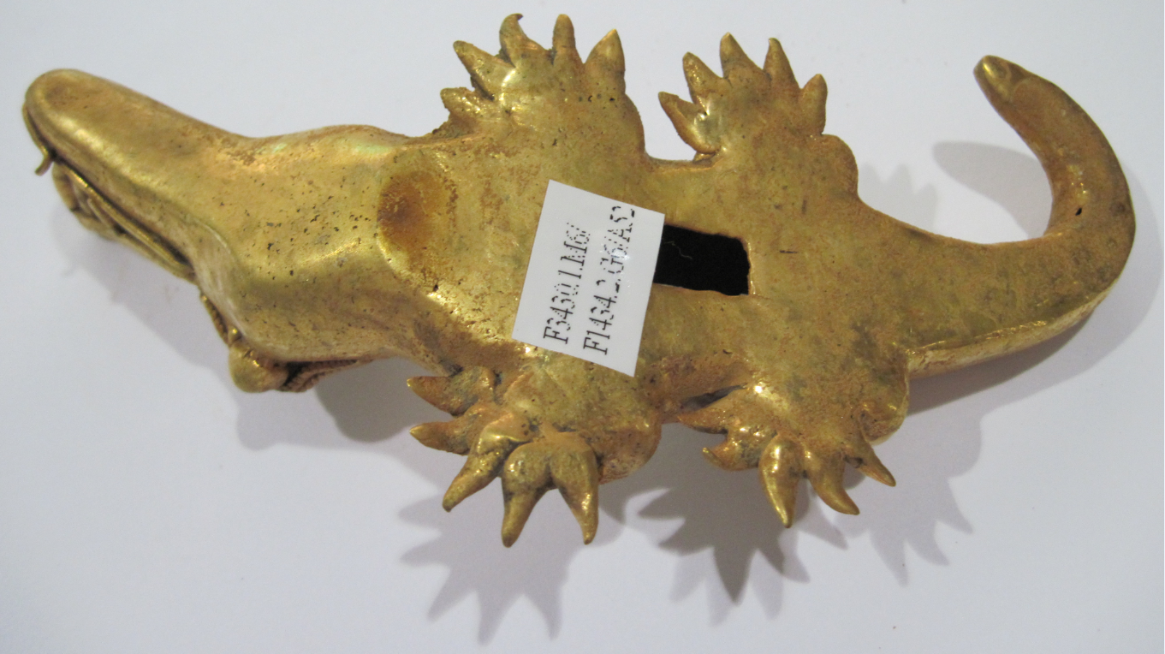

Figs. 1-3. Colombia-Tairona-Gold Figurine-*Crocodile*-1000-1500 AD/CE

**Case No.: 7**

**Formal Label:** Colombia-Tairona-Gold Figurine-*Crocodile*-1000-1500 AD/CE

**Display Description:** This gold figurine is of a mythic crocodile and was made by the lost wax process by the prehistoric Tairona culture (1000-1500 AD/CE) of the Sierra Nevada de Santa Marta**, NE Colombia**. By 1000 AD/CE Tairona goldsmiths, using the lost wax method, had attained one of the highest levels of technical and artistic achievement of gold-working in the Americas. The mythic crocodile,which otherwise might be dangerous, is the conduit of the classic shamanic initiation to *aluna*, the Tairona spiritual principle of being in harmony with the cosmos: “each being, even a small stone and the air, maintain the balance of the universe.” The crocodile in this case is the devouring one who ingests the aspirant, who then becomes skeletonized and then escapes and is reborn with shamanic capabilities to attain *aluna* (see Reichel-Dolmatoff 1945: 12-15; 1985: 38-43) to implement its goals: the protection of territory, the strengthening of oral tradition, sustainable development, food security and responsible consumption and harmony with the ecosystem” ([EÑES](https://translate.googleusercontent.com/translate_c?depth=1&hl=en&prev=search&rurl=translate.google.com&sl=es&sp=nmt4&u=https://medium.com/somos-enes%3Fsource%3Dfooter_card&usg=ALkJrhhV4slgnlp8CrzVzf2wyo-CDNCwag). 2017; see Coleridge 1950: cf. *aluna* and *natura naturans*).

**Accession Number:** A0000

**LC Classification:**  F1434.2

**Date or Time Horizon:** 1000-1500 CE

**Geographical Area:** Sierra Nevada de Santa Marta**, Colombia. Indigenous** Kogi **name** (*Gonawindua)****.***

**GPS Coordinates:** 10°57'N, 73°48'W.



Fig. 4. Map of Spanish Provinces in 1600. After <https://html2-f.scribdassets.com/5nmwqq7itc4aqx2e/images/6-a5a093175f.jpg>. Yellow place-holders mark the centers of the four Tairona cultures (in bold) as of 2017.

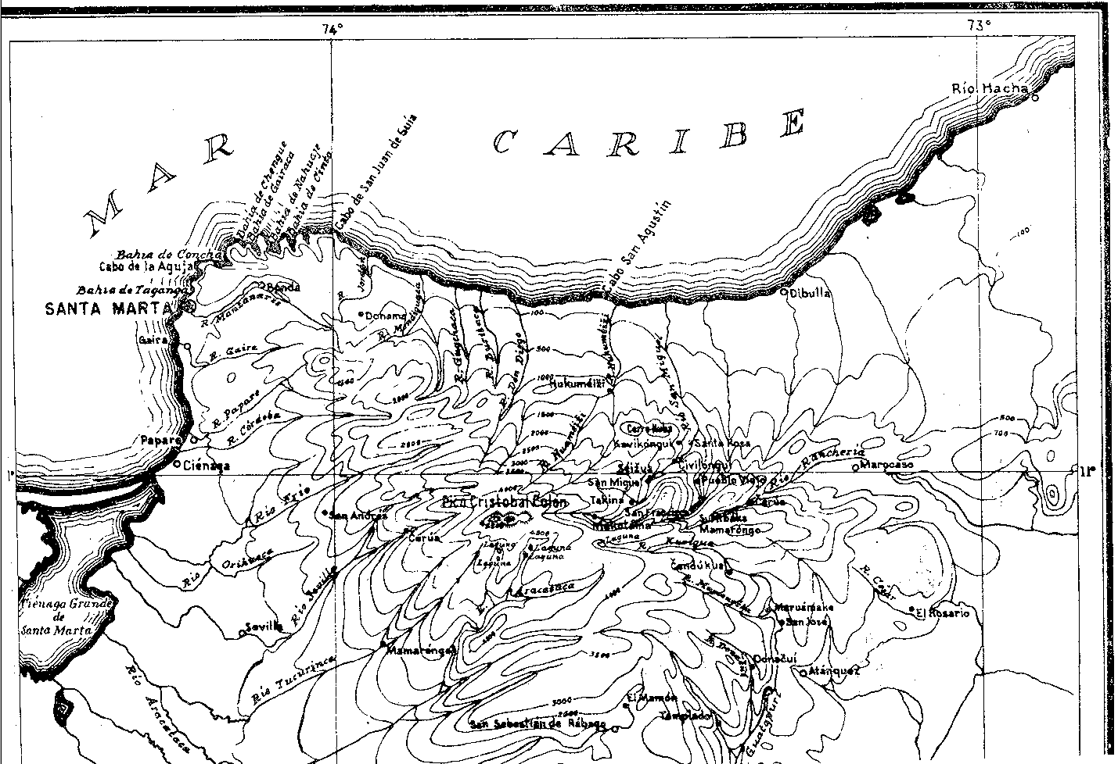

Fig. 5. Topographic map of the Sierra Nevada of NE Colombia. From Reichel-Dolmatoff 1950.

**Cultural Affiliation:** Tairona, Chibcha Language

**Medium:** Lost-wax cast of tumbaga, an alloy of gold and copper. Its surface was subsequently enriched by the depletion method, also known as *mise-en-couleur*.

**Dimensions:**

**Weight:**

**Condition: original**

**Provenance:** Tairona villages of the Kogi ethnolinguistic group. The four descendants of the Tairona are:

**Arhuaco (aka Aruaco, Bintuk, Bintukua, Binmticua, Ica, Ijka, Ika, Ike), pop. 14,301, (Arango and Sanchez 1998, SIL 2005); S slope,** 10°42'N, 73°38'W.

**Kankuamo (aka** Kankuaka, Kankui or Kankuané**), pop. 15,000 (**<https://en.wikipedia.org/wiki/Kankuamo>**;** Hammarström, Forkel, Haspelmath, Bank, 2016)**; S slope,** 10°45'N, 73°21'W

**Kogi** (aka Cogui or Kágaba, = “jaguar”), pop. 9,770 (SIL 2005, 1998 census); N, E, W slopes; 10°57'N, 73°48'W.  
**Malayo (aka** Arosario, **Arsaro,** Damana, Guamaca, Guarmaka, Guamaco, Maracasero, Sanja, Sanka, Wiwa) (**SIL 2005,** Hammarström, Forkel, Haspelmath, Bank 2016; pop. 7,000, Joshua Project 2017**): S, E slopes;** 10°56'N, 73°24'W.

**Discussion:**

The pre-Tairona period is known as the Nahuange Period (Bischof 1968) and is based on the stratigraphy of jadeite objects and the dating of gold artifacts excavated from coastal sites ranging from cal. AD/CE 130 ± 40 to cal. AD/CE 480 ± 40 (Bray 2003:324) in small, isolated, non-hierarchical towns and buildings without stone foundations (Giraldo 2010:181). Beginning ca 450 AD/BC pressure from the Caribs in the Orinoco River Valley caused an ethno-linguistic group, the Taino, to advance from the Orinoco River Valley into the Lesser and Greater Antilles. Kevin Menhinick, ["The Caribs in Dominica: Karifuna Cultural Group,"](http://www.hartford-hwp.com/archives/41/284.html) *Caribbean Taino News Service,* 1997.  During this Carib invasion Nahuange descendants, the Tairona, migrated from the lower to the upper slopes of the Sierra Nevada de Santa Marta and assembled non-hierarchical towns with circular stone foundations which they connected by flagstone trails (Rogonzinski 2000; Allaire 1997; Basso 1977).

# These trails suggest a desire to maintain a continuity of trade and exchange that they had developed for precious gems such as greenstone beads of the variscite-group minerals from Gran Roque Island and Barquimeto (Acevedo et al. 2017).

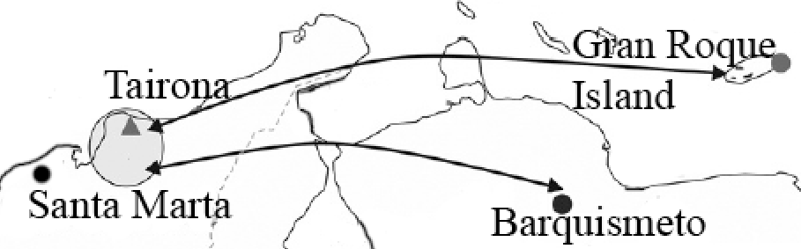

**|__________|** 300 km

Map of Tairona trade routes from Gran Roque Island and Barquismeto. After Acevedo et al. 2016, fig. 7.

Kogi **name** (*Gonawindua)*

Their mythology, dating from their Nahuange predecessors whose dwellings lie below those of the Tairona (Acevedo 2016; Dever 2007), views the highest mountain, which the Spanish named “Pico Cristobal Colon” to deny its indigenous religious power but which the Kogi **name it** *Gonawindua,* the “Holy Mountain.” Similarly, the Spanish gave the mountain massif the name of a Catholic Saint to again deprive it of its indigenous religious power, “Sierra de Santa Marta,” but the Tairona preserve its original name, “the Heart of the World.” Tairona mythology teaches that they are "Elder Brothers" of humanity and that those not living in the “Heart of the World” are called "Younger Brothers," the Caribs from the Orinoco Valley and by extension the Spanish and all those apart from the Tairona and their descendants (Cadavid y Herrera 1985; Groot 1985; Langebaek 2003, 2005; Oyuela-Caycedo1986, 1987; Reichel-Dolmatoff 1997; Serje 1987;Wynn 1975). When the Spanish arrived in the sixteenth century their Conquistador leader, Rodrigo de Bastidas, as he initiated the building of the city of Santa Marta in 1525 had the following proclamation read out on the beach (Tairona 2015)

  “I assure you that with the help of God I will enter powerfully against you, and I will make war on you in every place and in every way that I can, and I will subject you to the yoke and obedience of the church and their highnesses, and I will take your persons and your women and your children, and I will make them slaves, and as such I will sell them, and dispose of them as their highnesses command: I will take your goods, and I will do you all the evils and harms which I can, just as to vassals who do not obey and do not want to receive their lord, resist him and contradict him. And I declare that the deaths and harms which arise from this will be your fault, and not that of their highnesses, nor mine, nor of the gentlemen who have come with me here.”

In 1972, Colombian explorers in the rain forest ("Infierno verde" or "Green Hell") on the slopes of Sierra Nevada de Santa Marta discovered a previously unrecorded mountain trail of 1,200 stone steps, which led to an abandoned city (“Ciudad Perdida”; 11°02'22.9"N 73°55'33.8"W). There they discovered gold figurines and ceramic urns. However, Tairona descendants—the Arhuaco, the Kankuamo, the Kogi and the Malayo—reported that they called the 1,000 BCE site, Teyuna, and that it was the center of their network of ancient villages. The Tairona were forced to move into the highlands Teyuna consists of a series of 169 terraces and several small circular plazas.

Tairona spirituality is based on *aluna*, cosmic harmony. The Great Mother Creator, Gaulcováng (from gau – “to create”), has many manifestations, such as Hába Guxsénse, “Mother of the Eternal Fire,” and Málkwa-yang, “Mother of the Knowledge of Weaving.” Her children -- Lords of the Cosmos, Seokúkui and Seizankwa -- carry Gaulcováng’s Cosmic Egg balanced between two poles between them on their shoulders. When the Cosmic Egg shifts in balance between them, metaphorical earthquakes can result. The metaphysical may have physical consequences, so that right relations with one’s neighbors and the Earth (*natura naturans*) is essential to maintaining Cosmic balance.

The Cosmos is shaped like an egg in which there are the nine worlds that correspond to the nine months of human gestation (Tairona 2015).

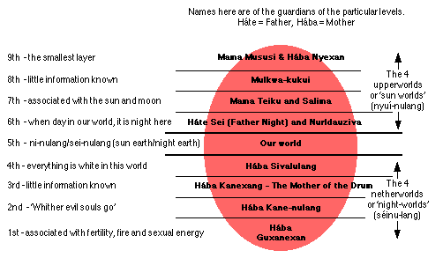

Fig. 6. Structure of the Tairona Cosmic Egg. Base on Reichel-Dolmatoff 1978 from Tairona 2015.

**References**

# Acevedo, Natalia , Marion Weber, Antonio García-Casco, and Joaquín Antonio Proenza. 2016. “A First Report of “Variscite Tairona Artifacts (A.D. 1100-1600) from the Sierra Nevada de Santa Marta, Colombia, and Its Implications for Pre-Columbian exchange Networks in the Region,” *Latin American Antiquity* 27(4): 549-560.

Adelaar, Willem F. H. and Pieter Muysken. 2004. [The Languages of the Andes](https://books.google.com/books?id=UiwaUY6KsY8C&pg=PA75). Cambridge: [Cambridge University Press](https://en.wikipedia.org/wiki/Cambridge_University_Press).

Allaire, Louis. "The Caribs of the Lesser Antilles." In Samuel M. Wilson,*The Indigenous People of the Caribbean*. Gainesville, FL: University of Florida Press, 1997.

# Basso, Ellen B. *Carib-Speaking Indians: Culture, Society, and Language*. University of Tucson, AZ: Arizona Press, 1977.

Bischof, H. 1982-1983. “Indígenas y españoles en la Sierra Nevada de Santa Marta, siglo XVI,” *Revista Colombiana de Antropología*, 24: 75-124

Bray, W. 2003. “Gold, Stone, and Ideology: Symbols of Power in the Tairona Tradition of Northern Colombia.” In Quilter J., J. W. Hoopes (eds.), *Gold and Power in Ancient Costa Rica, Panama, and Colombia*. (Washington: Dumbarton Oaks Pre-Columbian Conference Proceedings), pp. 301- 344.

Cardoso P.1987. “Uso y significado de las cuentas tairona,” *Boletín del Museo del Oro*, 19: 117-123.

Coleridge, Samuel Taylor. 1950. *The philosophical lectures hitherto unpublished*. Ed. K. Coburn. London: Routledge and Kegan Paul.

D'Anghiera, Peter Martyr. 1555. *De Orbo Novo*. Trans. Richard Eden as *The decades of the newe worlde or west India conteynyng the nauigations and conquestes of the Spanyardes with the particular description of the moste ryche and large landes and Ilands lately founde in the west Ocean perteynyng to the inheritaunce of the kinges of Spayne*, Book III, §3. London: William Powell.

[EÑES](https://translate.googleusercontent.com/translate_c?depth=1&hl=en&prev=search&rurl=translate.google.com&sl=es&sp=nmt4&u=https://medium.com/somos-enes%3Fsource%3Dfooter_card&usg=ALkJrhhV4slgnlp8CrzVzf2wyo-CDNCwag). 2017. La Biblioteca como protectora del mundo. https://about.me/souldes.

Ereira, Alan. 1993. [The Elder Brothers](http://www.amazon.com/Elder-Brothers-Alan-Ereira/dp/0679743367/ref=tmm_pap_swatch_0?_encoding=UTF8&sr=&qid=). New York: Vintage Books.

Falchetti A.M. 1987. “Desarrollo de la orfebrería Tairona en la provincia metalúrgica del norte

Colombiano,” *Boletín del Museo del Oro*, 19: 3-23.

Fabré, Alain. 2005. [Diccionario etnolingüístico](http://www.ling.fi/Entradas%20diccionario/Dic=Chibcha.pdf) *y guía bibliográfica de los pueblos indígenas sudamericanos.* Internet Electronic File.

Frank, Paul S. 1992. “Reconstrucción de las variaciones en Proto-Aruaco,” *Thesaurus (*Bogotá)47: 532-542.

1993. “Proto-Arhuacan phonology,” *Estudios de Lingüística Chibcha,* 12: 95-117.

Gutierrez Hinojosa, Tomas Dario. 2000. Valledupar Musica de una Historia. Bogota: Editorial Grijalbo LTDA.

Hammarström, Harald; Forkel, Robert; Haspelmath, Martin; Bank, Sebastian, eds. 2016. ["Kankuamo"](http://glottolog.org/resource/languoid/id/kank1244). [*Glottolog 2.7*](https://en.wikipedia.org/wiki/Glottolog). Jena: Max Planck Institute for the Science of Human History.

Joshua Project. 2017. <https://joshuaproject.net/people_groups/13448/CO>

Legast, A. 1982. “La fauna mítica Tairona,” *Boletín del Museo del Oro*, 13:1-18

Legast, A. and A. Cadena. 1986. “El murcielago en el material arqueologico, colombiano,” *Boletín de arqueología*, 1(3): 25-34.

Mason, J.A. 1931. *Archaeology of Santa Marta. The Tairona Culture.* Part 1. Antropological Series, 20(1). Chicago: Field Museum of Natural History.

1936. *Archaeology of Santa Marta. The Tairona Culture.* Part 2. Section 1. Objects of stone, shell, bone and metal. Anthropological Series, 20(2): 1. Chicago: Field Museum of Natural History.

National Institutes of Health; Committee to Review the Health Effects in Vietnam Veterans of Exposure to Herbicides. 1994. [*Veterans and Agent Orange: Health Effects of Herbicides Used in Vietnam*](https://books.google.com/books?id=2YQTHJlt5l4C&pg=PA90). Washington: National Academies Press.

Oyuela-Caycedo, A. 1986. “De los Tairona a los Kogi: Una interpretación del Cambio Cultural,” *Boletín del Museo del Oro*, 17: 32-43

2005. “El surgimiento de la rutinización religiosa: los orígenes de los tairona-kogis.” In Chaumeil J.P., R.P. Camacho, J.F. Bouchard (eds.), *Chamanismo y sacrificio, Persectivas arqueológicas en sociedades indígenas de América del  Sud*. Bogotá, pp. 141-163

2010. “The Forest as a Fragmented Archaeological Artifact.” In Dean R.M. (ed.), *The Archaeology of Anthropogenic Environments*. Carbondale: University of Michigan Press, pp.75-94.

Panoramas. 2015.<http://www.viewfinderpanoramas.org/panoramas.html#longlines>

González-Plazas, Santiago. 2008. Pasado y presente del contraband en La Guajira aproximaciones al fenómeno de ilegalidad en la region. Centro de Estudios y Observatorio de Drogas y Delito Facultad de Economía, Universidad del Rosario, Bogotá.

https://www.bing.com/search?q=Pasado%20y%20Presente%20del%20Contrabando%20en%20La%20Guajira%20Aproximaciones%20al%20Fenomeno%20de%20ilegalidad%20en%20la%20Region&pc=cosp&ptag=C1N13A005A2B4283&form=CONBDF&conlogo=CT3210127

Plazas, C. 1987. “Forma y fución en el oro Tairona,” *Boletín del Museo del Oro*, 19: 25-33.

Réclus, Élisée. 1875-94. La Nouvelle Géographie universelle, la terre et les hommes, 19 vol. Paris.

Reichel-Dolmatoff, Gerardo.1942. "Apuntes arqueológicos de Soacha," *Revista del Instituto Etnológico Naccional*, pp. 15-25.

1945. “Mitos y cuentos de los indios Chimila,” *Boletin de Arqueologia* 1(1): 4-30.

1950-1951. *Los Kogi : una tribu de la Sierra Nevada de Santa Marta, Colombia*. Bogotá: Editorial Iqueima. 2v.

1953a. “Contactos y cambios culturales en la Sierra Nevada de Santa Marta,” *Revista Colombiana de Antropología* 1(1): 15-122.

1953b. “Investigaciones arqueológicas en el departamento del Magdalena: 1946-1950. Parte III: arqueología del bajo Magdalena,” *Divulgaciones Etnológicas* 4(4): 1-96 + 23 láminas. Barranquilla: Instituto Etnológico del Atlántico.

1954a. “Investigaciones Arqueológicas en la Sierra Nevada de Santa Marta. Partes 1-2”. *Revista Colombiana de Antropología,* 2(2): 147-206.

1954b. “Investigaciones Arqueológicas en la Sierra Nevada de Santa Marta. Parte 3”. *Revista Colombiana de Antropología,* 3(3): 141-170.  
  
1959. “La Mesa. Un complejo arqueológico de la Sierra Nevada de Santa Marta,” *Revista Colombiana de Antropología,* 8: 159-214.

1963. “Investigaciones arqueológicas en la Costa Pacífica de Colombia II- Una secuencia cultural del Bajo Río San Juan,” *Revista colombiana de antropología,* 2: 9-81.

1990. “The Sacred Mountain of Colombia’s Kogi Indians,” *Iconography of Religions*, sec. 9, South America, fasc.2, Serie M. Leiden.

1997. *Arqueología de Colombia: Un texto introductorio* (1986)*.* Bogotá: Imprenta Nacional de Colombia.

Reichel-Dalmatoff, Gerardo and Alicia Dussan de Reichel. 1942. "Las urnas funerarias en la cuenca del río Magdalena," *Revista del Instituto Etnológico Nacional*, Bogotá, pp. 109-160.

1951. “Investigaciones arqueológicas en el departamento del Magdalena: 1946-1950,” Parte I: “Arqueología del río Ranchería; Parte II: “Arqueología del río Cesar,” *Boletín de Arqueología,* III(1-6): 1-334. Bogotá: Instituto Etnológico Nacional.

1955. “Investigaciones arqueológicas en la Sierra Nevada de Santa Marta. Parte IV: sitios de habitación del período Tairona II, en Pueblito,” *Revista Colombiana de Antropología,* 4: 189-245.

1961. "Investigaciones arqueológicas en la costa Pacífica de Colombia :I - El sitio de Cupica" *Revista colombiana de antropología,* Bogotá. 10: 237-317.

Jan Rogonzinski, *A Brief History of the Caribbean: From the Arawak and Carib to the Present* (Plume, 2000

1987. “Arquitectura y Urbanismo en la Cultura Tairona.” *Boletín del Museo del Oro,* 19: 87-96.

SIL International *et al*. 2005. *Ethnologue: Languages of the World*. Dallas, Texas: SIL International.

Tairona. 2015. <http://tairona.myzen.co.uk/>).

Vinalesa, José de. 1952. *Los indios arhuacos de la Sierra Nevada de Santa Marta*. RIEN. Bogotá: Editorial Iqueima.